Assignment no 8

1) Assume each salesperson has a 12% commission. Write a query on the orders table that will produce the order number , salesperson number, & amount of salesperson’s commission for that order.

Ans :-

select onum,snum, amt*.12 comm from ORDERS;

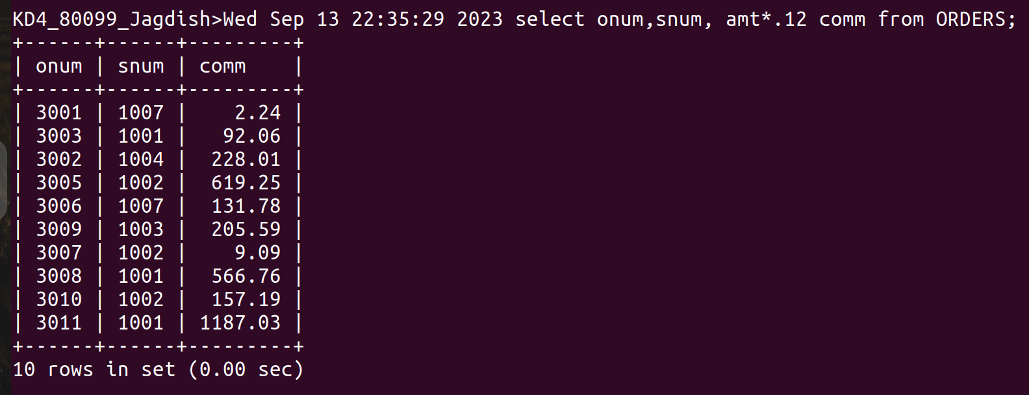
2) Write a query on the Customers table that will find the highest rating in each city. Put the output in this form:
For the city (city), the highest rating is :(rating).

Ans:-
select concat(city,' the highest rating is:', max(rating)) as High_Rating from CUSTOMERS
group by city;

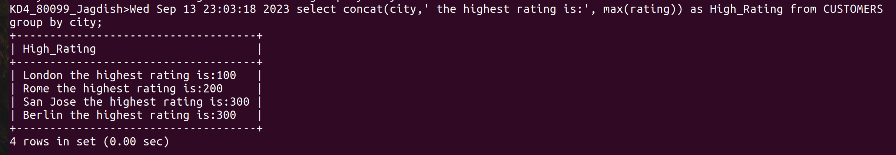

3) Write a query that lists customers in descending order of rating. Output the rating field first, followed by the customers’s name and number.

Ans :-
select rating,cname from CUSTOMERS order by rating desc;

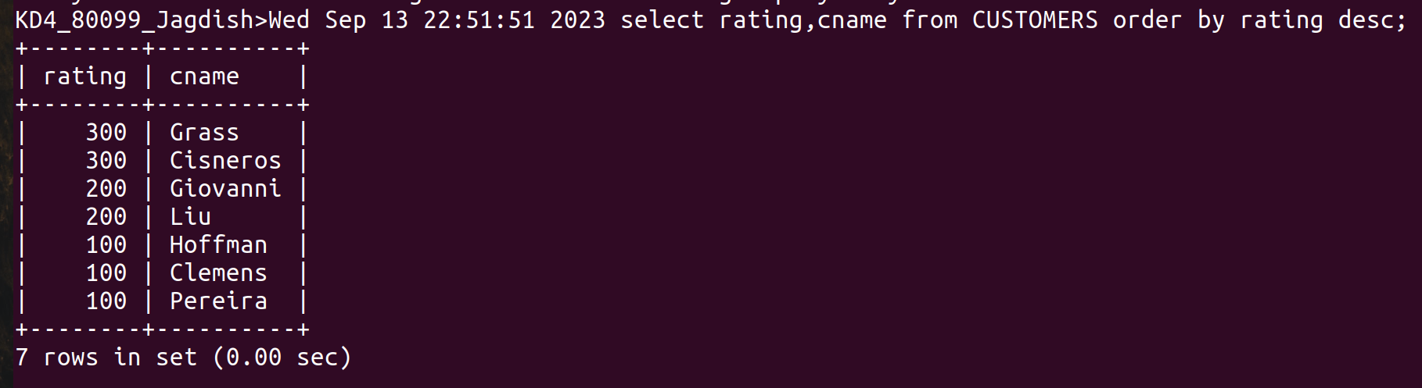
4) Write a query that totals the orders for each day and places the results in descending order.
Ans :-

select count(*) as totals from ORDERS group by odate order by 1 desc;

